–

Washing Machine

Company

Logotype

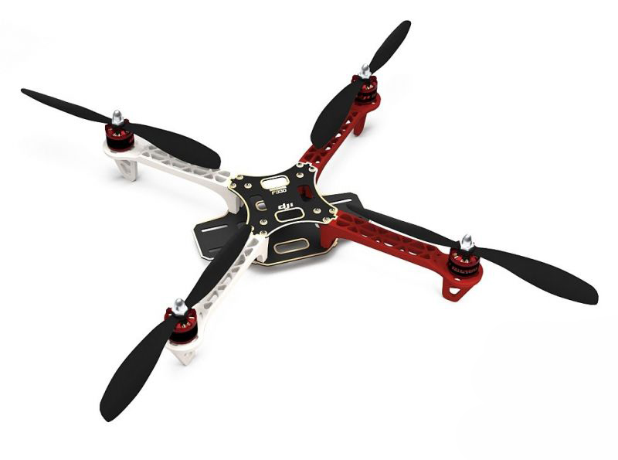

**Students**

**Aws Abdulhamed**

**Autonomous Control of a Quadrotor UAV using Fuzzy Logic**

**Supervisor : Dr.Tarek Barhom**

**Introduction**

UAV’s are being increasingly used today than ever before in both military and civil applications A certain level of autonomy is imperative to the future of UAV’s.

A quadrotor “ one of UAV “ is a helicopter with four rotors .

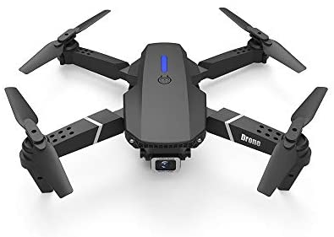

Quadrotor

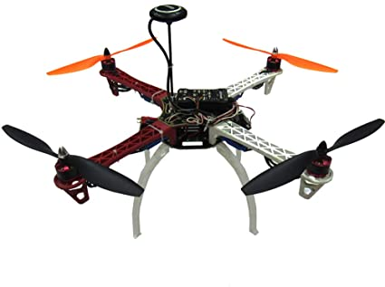

Quadrotor

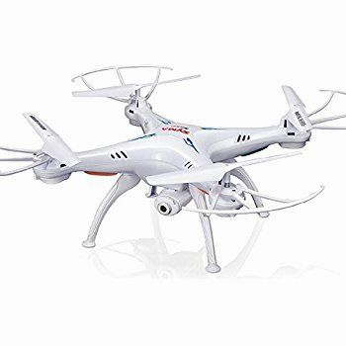

Quadrotor

There are many Design - outside look - of Quadrotor but still have the same core design which is have 4 arms that hold motors and a central area contain the computing device and other requirements such as battery, sensors and function tools as camera.

By definition Quadrotor is an emerging popular rotary wing UAV platform, which is gaining focus in realizing micro aerial vehicle concepts, It is a helicopter with four rotors, two spinning clockwise and two anticlockwise, thereby maintaining net zero moment on other hand still Stabil .

A Quadrotor is an under actuated system with six DOF **Six degrees of freedom** (**6DoF**) and **four control outputs**.

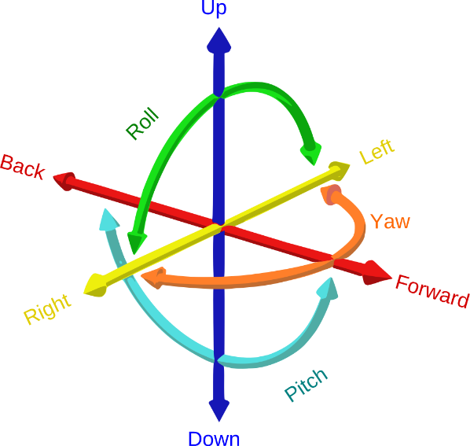**Six degrees of freedom** (**6DoF**) :  refers to the freedom of movement of **a**[**rigid body**](https://en.wikipedia.org/wiki/Rigid_body) **“** solid [body](https://en.wikipedia.org/wiki/Physical_body) **“** in [three dimensional space](https://en.wikipedia.org/wiki/Three-dimensional_space). Specifically, the body is free to

1. **change**[**position**](https://en.wikipedia.org/wiki/Position_(geometry)) :
   * + **forward / backward** (surge).
     + **up / down** (heave).
     + **left / right** (sway).

[**translation**](https://en.wikipedia.org/wiki/Translation_(physics)) in three [perpendicular](https://en.wikipedia.org/wiki/Perpendicular) [axes](https://en.wikipedia.org/wiki/Coordinate_axis) .

1. **changes** [**orientation**](https://en.wikipedia.org/wiki/Orientation_(geometry)) :
   * + **yaw** (normal axis),
     + **pitch** (transverse axis),
     + **roll** (longitudinal axis).

[**rotation**](https://en.wikipedia.org/wiki/Rotation) about three perpendicular axes .

It is simple in design and construction as compared to a scaled single rotorcraft, but presents an interesting control challenge.

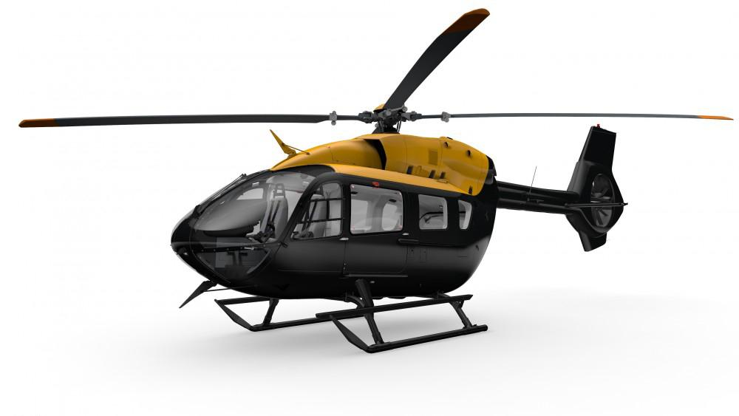

Rotorcraft

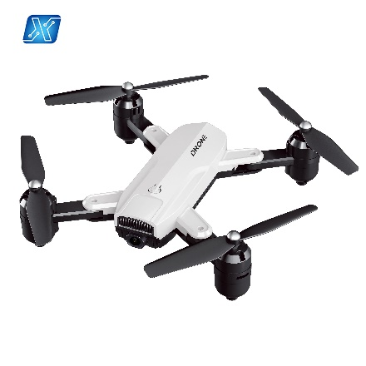

Quadrotor

Fuzzy logic control has been chosen to address this control problem as it can effectively deal with highly nonlinear systems and provides sufficient solution , Modularity and adaptability are key advantages to the fuzzy logic approach.

Genetic algorithms while providing good results in simulation are not suited for real time control applications.

**System Specification**

A comprehensive description of the system developed :

1. System Building “ Hardware “ .
2. System modelling “ Software “ .

Our focus will be on System modelling but an overview of Building will be mentioned

**System Building “ Hardware “**

The Quadrotor developed has

1. Four rotors symmetrically distributed around a central cabin that houses the electronics .
2. Two cross arms .
3. Battery .
4. Etc…..

**System modelling “ Software “**

The mathematical model presented was used to develop a simulation environment in MATLAB/Simulink to facilitate the development of proposed control strategy .

Extensive simulations were performed to validate the flight controller and fine tune parameters of the fuzzy inference system .

The quadrotor is a complex mechanical system it collects numerous physical effects from the aerodynamics and mechanics domain such as **ground effect**, **gyroscopic effects**, **airflow interactions**, **propeller flapping** , etc ….

**were studied but not modeled due to their complexity**

**System Specification**

Details out the development of a mathematical model of a quadrotor. The complete derivation of the kinematics and dynamics, along with an understanding of reference frames and coordinate systems, is provided.

Forces and torques acting on the quadrotor and their effects are  
interpreted .

**Reference frames :**

Axis systems provide a reference point or origin and a sense of positive displacement , use of several different reference systems is essential to make analysis simpler , The coordinate frames are transformed into one other through rotations and translations.

Sensors constituting the onboard IMU give readings with respect to the body frame. Forces and torques acting on the quadrotor are also evaluated in the body frame.

1. 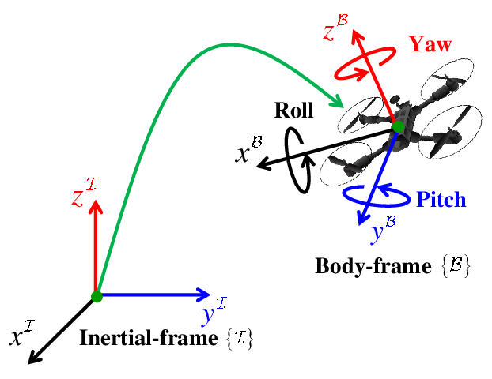**The inertial frame**, is an Earth-fixed coordinate system with its origin located conveniently at the base station. It is the conventional North, East and Down (NED) frame.



1. **The body frame**, has its origin at the COG of the quadrotor with its x-axis pointing forward along motor 1, y-axis pointing out to right along motor 2 and z-axis pointing out the belly.



1. **The vehicle-carried NED frame**, has its axes aligned with the inertial NED frame but has its origin at the COG of the quadrotor.



Each frame can be obtained from another by performing translations and rotations.

Examples :

The vehicle frame can be transformed into the inertial frame by undergoing a pure translation.

The body frame can be obtained from the vehicle frame by a series of rotations in a specific order.

**Let us define two more intermediate frames to illustrate this:**

* The frame Fv-1 is obtained by rotating ( Fv ) positively about ( Zv ) by the yaw angle ψ this means if roll and pitch angles are zero it now coincides with the body frame .
* The frame ( Fv-2 ) is obtained by rotating this ( Fv-1 ) about the ( Yv-1 ) by the pitch angle ( θ ) in a positive sense Now if this frame is rotated about the ( Xv-2 ) by the roll angle ( φ ), we obtain the body frame .

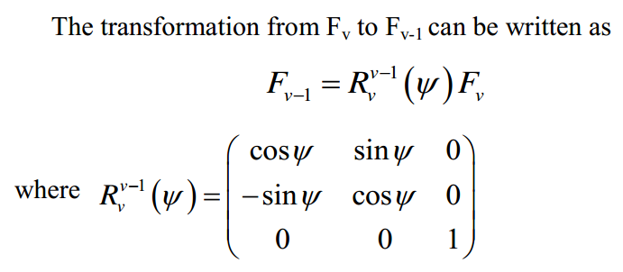

Rotate according to Z-axis

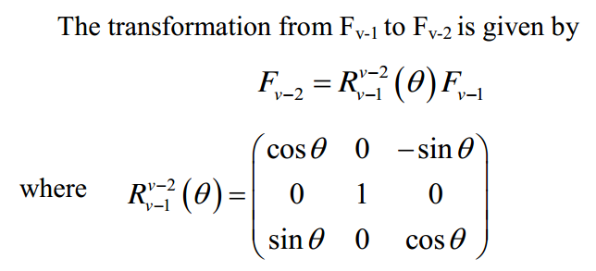

Rotate according to Y-axis

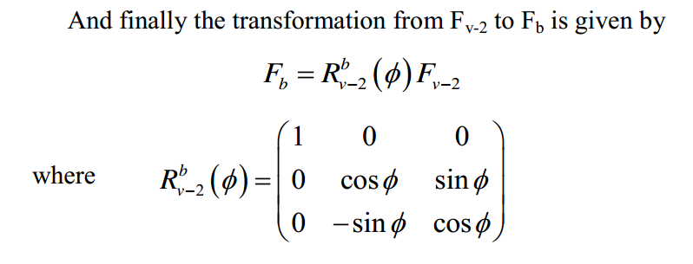

Rotate according to X-axis

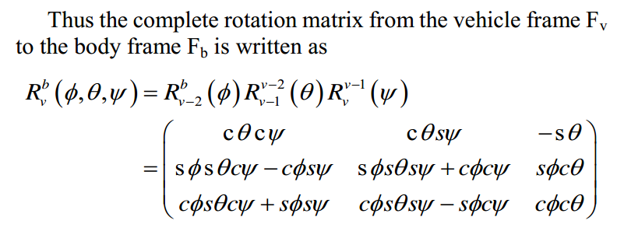

**In conclusion :**

**We can transform from body frame to vehicle frame via Yaw rotation by (ψ) angle of Z-axis Rotation .**

**We can transform from body frame to inertial frame via Yaw rotation by (ψ) Z-axis and pitch** **rotation ( θ ) Y-axis and roll** **rotation ( φ ) X-axis .**

**Kinematics :**

The 6 DOF equations of motion (EOM) are more easily formulated in the body frame due to the fact that, the on board IMU measurements are in this frame, the control forces are given in this frame and the symmetry of the quadrotor simplifies equations .

The Euler angles are defined in the vehicle frame Fv and its variations Fv-1 and Fv-2.

The following vector notation will be used at all times

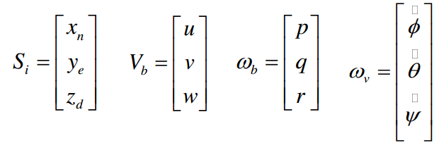

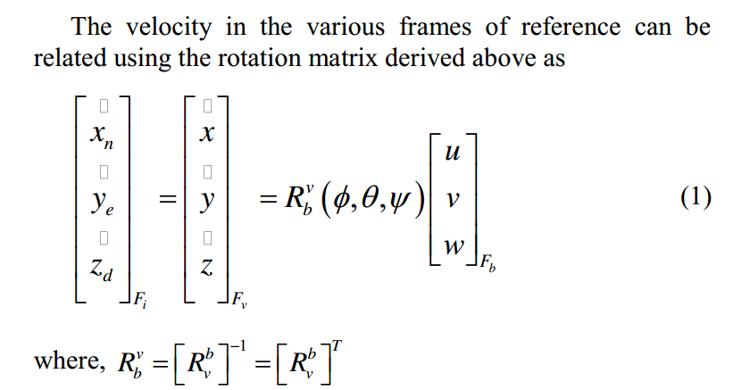

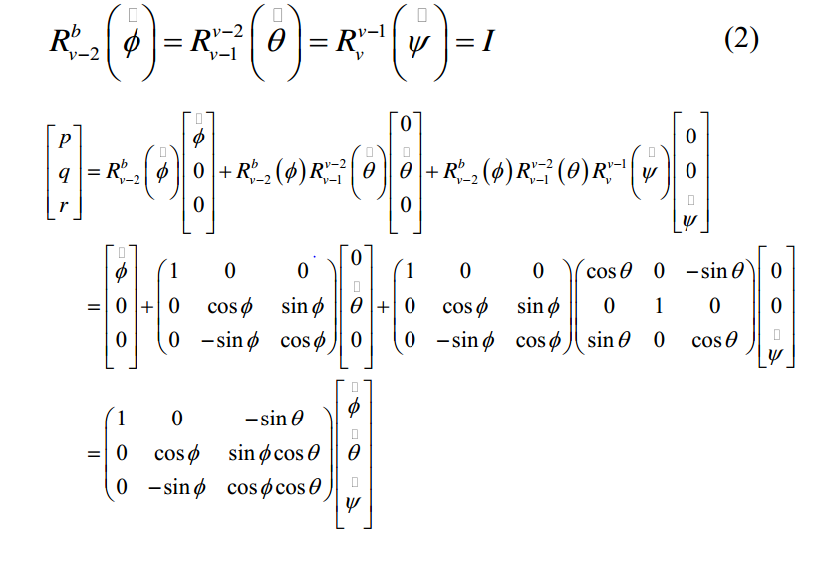

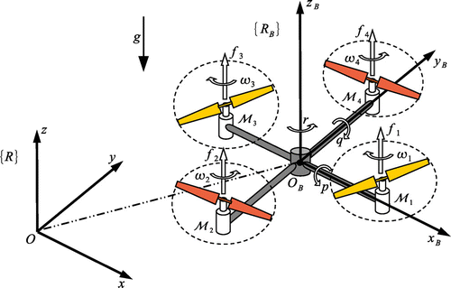

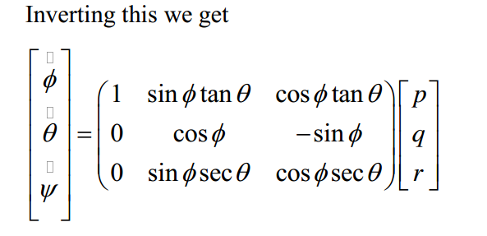

**Dynamics:**

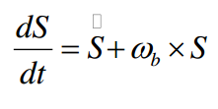Differentiation in a moving axis system is given by

Where S is the position vector of a particle relative to the origin of the moving body frame and ωb is the angular rate that the body frame is moving with respect to an inertial frame.

Newton’s laws of motion are only valid in inertial frames, thus we need the above relation to formulate our equations of motion in the body frame .

Let Fext be the force vector containing all external forces including gravity , Mass being constant.

applying the above equation and the chain rule of differentiation, we can concisely write the linear EOM as :

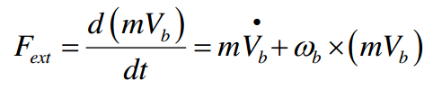

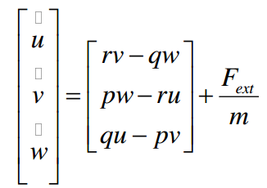Thus using our previously defined notation, this becomes :

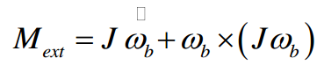Let Mext=[L M N]T be the moment vector containing all external moments developed, then the angular EOM can be written as :

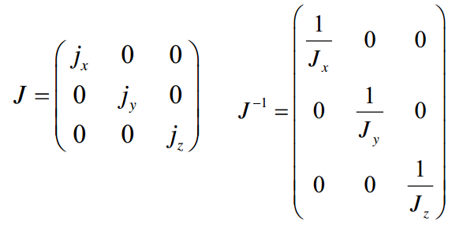

The quadrotor is completely symmetrical about all its axes this conveniently renders the cross terms in the inertia matrix J to be zero.

Thus Jxy = Jyz = Jxz = 0 and our inertia matrix J is given by

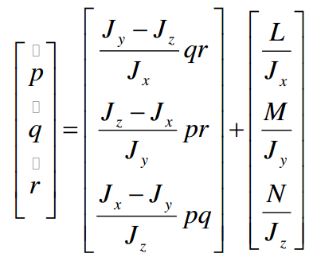Thus the angular EOM can be written as :

**Forces and Moments**

The forces and moments developed are due to gravity and the thrust and torques developed by the four propellers .

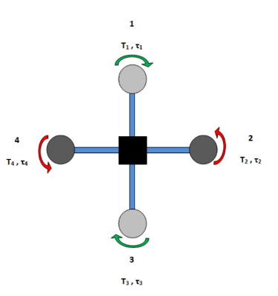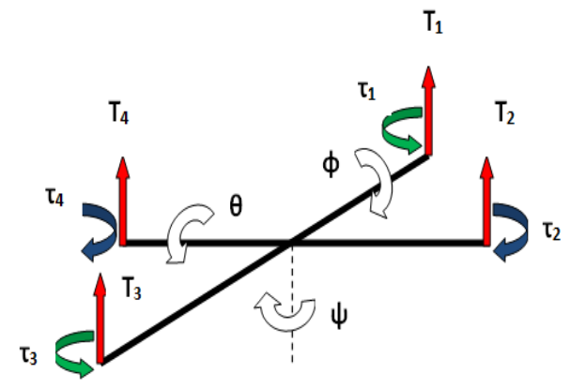

The total force acting on the quadrotor is :



The rolling ( X-axis ) torque L is produced by the thrust difference between motors 2 and 4 as:



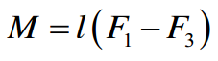The pitching ( Y-axis ) torque M is produced by the thrust difference between motors 1 and 3 as:

The yawing ( Z-axis ) torque N is produced by the total difference in clockwise and counter clockwise torques generated by all four motors as :

Fext thus has only a fz component i.e. –T, but the gravitational force also needs to be given in the body frame :

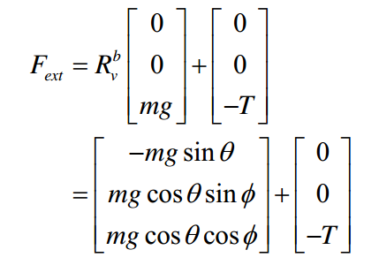

Thus equations become

Rotation Equation

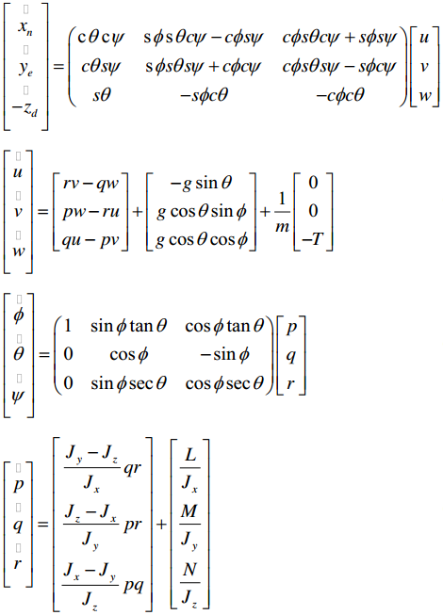

Moving Equation

**FUZZY FLIGHT INFERENCE SYSTEM**

Fuzzy logic manipulates inputs using the heuristically developed rule base and converts them into outputs.

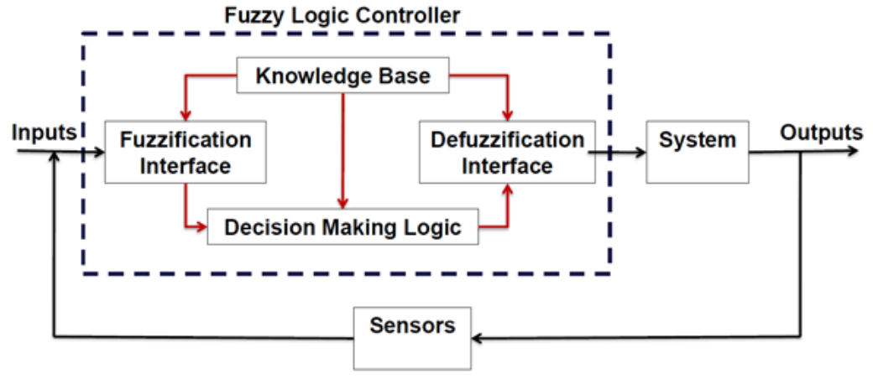

The flight controller must perform two separate tasks simultaneously:

1. Stabilize the attitude of the Quadrotor.
2. Control the position of the Quadrotor by manipulating its attitude.

The mathematical model illuminates the fact that X and Y motions are coupled with pitching and rolling motions respectively.

Thus in all six states namely

1. X-Coordinate.
2. Y-Coordinate.
3. Z-Coordinate.
4. heading angle (ψ).
5. roll angle (φ).
6. pitch angle (θ) .

have to controlled simultaneously.

Accordingly, six FLC’s have been designed, one FLC to control each state.

* 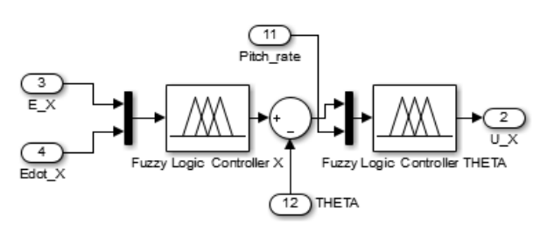The FLC X cascaded with FLC θ
* 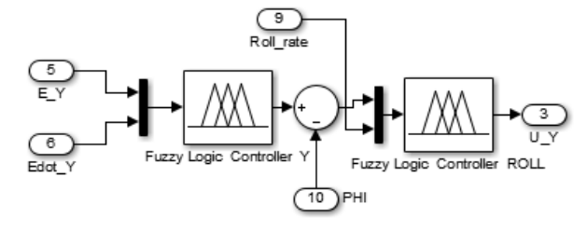The FLC Y cascaded with FLC φ
* 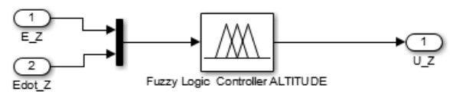FLC Z standalone controller
* 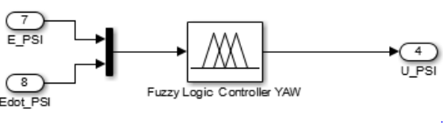FLC ψ standalone controller

* Each FLC has two inputs namely the error and error rate and one output which is the Δ PWM value.
* MATLAB’s Fuzzy Logic toolbox was used to develop the controllers, which use the Mamdani-type inference method and the centroid method for defuzzification.
* A predefined bias “offset” is used to counteract the weight of the Quadrotor.
* Translation in is achieved by:

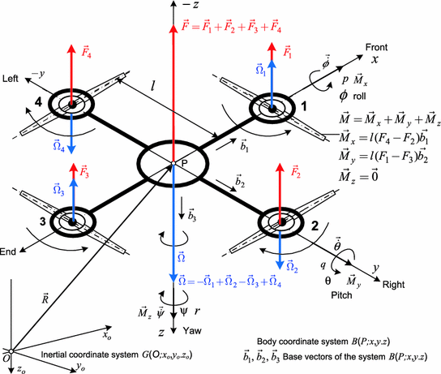

**Translation in the +X direction is achieved by**

a pitch down i.e nose down movement.

PWM_1 = offset – uX

PWM_3 = offset + uX,

while the other motors are unaffected PWM_2 = PWM_4 = offset.

Similarly ±Y translation is achieved by rolling right/left respectively, altering the speeds of motors 2 and 4, and keeping that of 1 and 3 constant

Z translation is achieved by increasing or decreasing the speeds of all the motors by the same amount



**Control of the heading angle requires an unbalanced torque.**

this is manipulated by either increasing speeds of the clockwise motors (1, 3) and decreasing that of the counter clockwise motors (2, 4) by the same amount, or vice versa thus producing an anticlockwise or clockwise net moment.

**Membership Functions**

Each of the three attitude FLC’s and the altitude FLC is setup in the following manner: **Two inputs** to the fuzzification interface i.e. the error and error rate of the particular state to be controlled and **one output** which is the motor output control value.

The two positional FLC’s namely FLC X and FLC Y are setup slightly differently: Two inputs to the fuzzification interface i.e. the error and error rate of the X and Y state to be controlled and one output which are the required Pitch and Roll angle to achieve that position respectively.

For example, considering the FLC X positional controller, its inputs and output would be:

1. INPUT_1 error_X = Des_X – Actual_X

2. INPUT_2 error_rate = Actual_X_Velocity

3. OUTPUT Required Pitch angle θ

This output of the positional controller is then fed to the attitude controller thus closing the outer and inner loops.

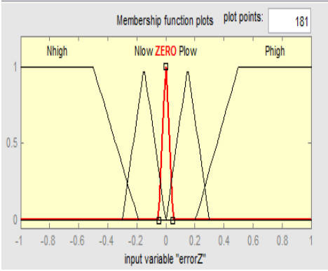**The error input to all the FLCs consists of five membership functions and is normalized to the range [-1 1] .**

1. **Negative High**
2. **Negative Low**
3. **Zero**
4. **Positive Low**
5. **Positive High**

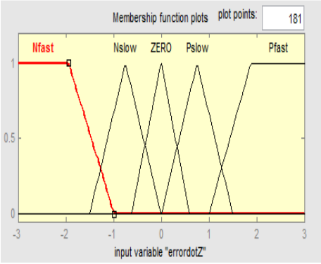**The error rate input for all the FLCs also consists of five membership functions.**

1. **Negative Fast**
2. **Negative Slow**
3. **Zero**
4. **Positive Fast**
5. **Positive Slow**

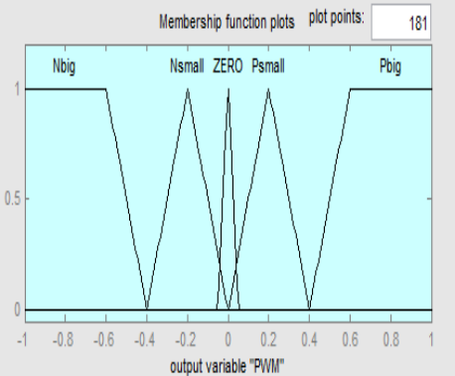**The output of each of the FLCs comprises of the following five membership functions.**

1. **Negative Big**
2. **Negative Small**
3. **Zero**
4. **Positive Small**
5. **Positive Big**

**Rule Base**

Rules are developed as if-then statements based on heuristics and experience. For example,

**IF** errorZ is “Nhigh” **and** errordotZ is “Pfast” **THEN** PWM is “Nbig”.

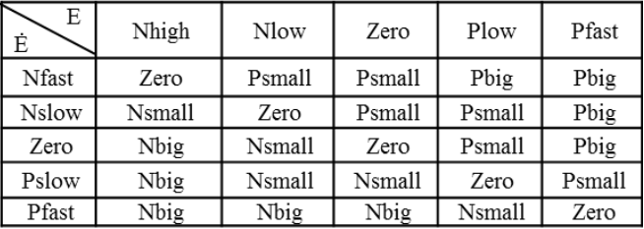if actual altitude is much higher than desired, thus error is negative high, and the error rate i.e. velocity in Z direction is positive fast meaning a high upward velocity, then the output is negative big.

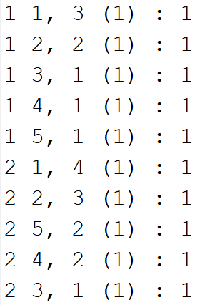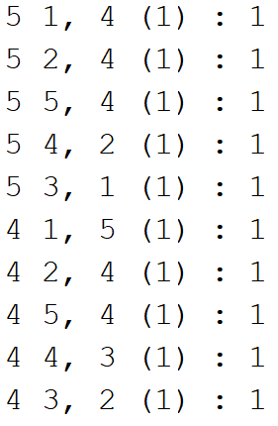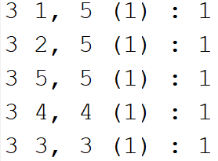

**Quadrotor Simulink Model**

The closed loop controller and the Quadrotor simulator have been implemented in MATLAB Simulink.

The inputs to the Quadrotor block are the four motor PWM values, it outputs the linear and angular accelerations that are twice integrated to obtain linear and angular velocities and positions.

The EOM are embedded in the Quadrotor block of the simulator.

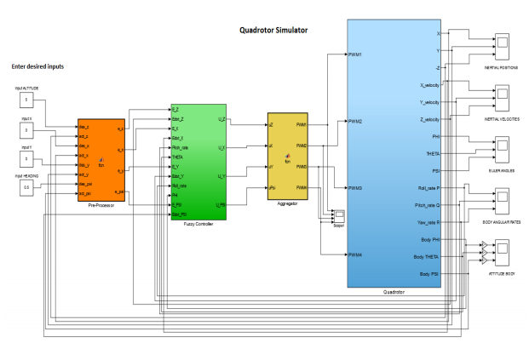

**ATTITUDE FIS EVALUATION**

* **First Way**

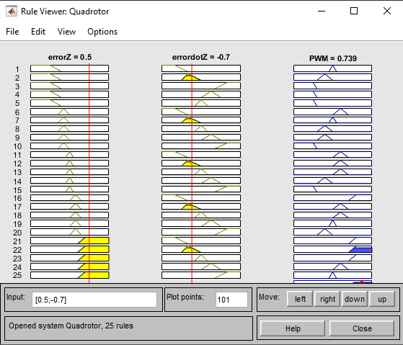

* **Second way**

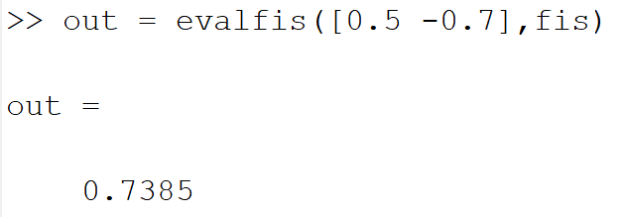

* Third Way

